# System Test Case

The purpose of a test case is to describe how you intend to empirically verify that the software being developed conforms to the specifications. In other words, you need to be able to show that it can correctly carry out its intended functions.

## Test Case Description

A test case contains all the information necessary to verify some particular functionality of the software.

*Below are Riki Tours test cases:*

### Test case 1: Registration

**Purpose**: Verify that a member can properly register.

**Requirement Traceability**: Download Riki Tours App.

**Setup**: The Riki Tour app is started.

**Test Data**:

|  |  |  |
| --- | --- | --- |
| **Action** | **Input** | **Expected Output** |
|  |  | Home Screen |
| Click Register. |  | Registration Screen |
| Enter your personal details. | First Name: “test” Last Name: “test” Gender: “Male” Email Address: “test@gmail.com Password: “1234” Confirming Password: “1234” |  |
| Accept Terms and Conditions and Click Register. |  | “Successfully Registered” then Home Screen. |

### C:\Users\bishop v\Desktop\app pics\log in .pngC:\Users\bishop v\Desktop\app pics\registration .png

### Test case 2: Login

**Purpose**: Verify that a member can properly login.

**Requirement Traceability**: A member must be registered.

**Setup**: The Riki Tour app is started.

**Test Data**:

|  |  |  |
| --- | --- | --- |
| **Action** | **Input** | **Expected Output** |
|  |  | Home Screen |
| Enter your login details and Click Login. | Email Address: “test@gmail.com Password: “1234” | Riki Tours Menu Screen |

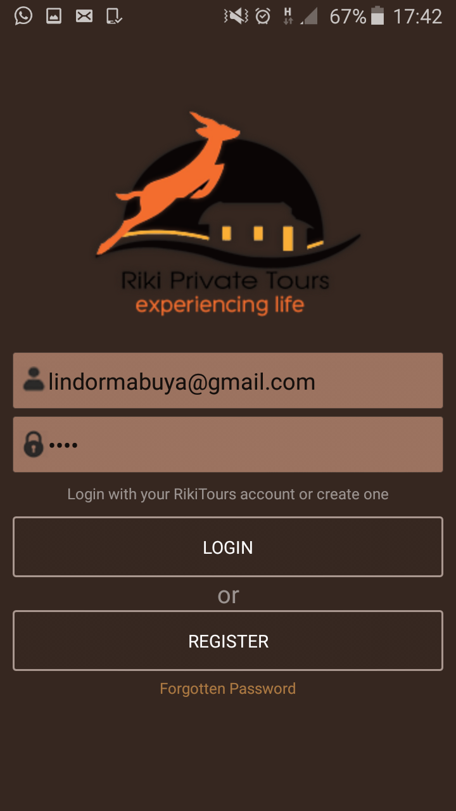

### Test case 3: Private Tour Quote

**Purpose**: Verify that a member can properly quote for a private tour.

**Requirement Traceability**: A member must be registered. And be on menu Screen

**Setup**: The Riki Tour app is started and member logs in.

**Test Data**:

|  |  |  |
| --- | --- | --- |
| **Action** | **Input** | **Expected Output** |
|  |  | Menu Screen |
| Click Discovery Tours |  | Attraction Screen |
| Click Read More |  | Detail Screen per Attraction |
| Click Get a Quote |  | “Quote request successfully received” |
| Click Gallery |  | Attraction Gallery |



### Test case 4: Car Rental

**Purpose**: Verify that a member can properly reserve a vehicle.

**Requirement Traceability**: A member must be registered. And be on menu Screen

**Setup**: The Riki Tour app is started and member logs in.

**Test Data**:

|  |  |  |
| --- | --- | --- |
| **Action** | **Input** | **Expected Output** |
|  |  | Menu Screen |
| Click Car Rental |  | Vehicle Screen |
| Click Book and Enter Details. |  | Reservation Screen |
| Click Make Reservation |  | “You successfully made a reservation” |

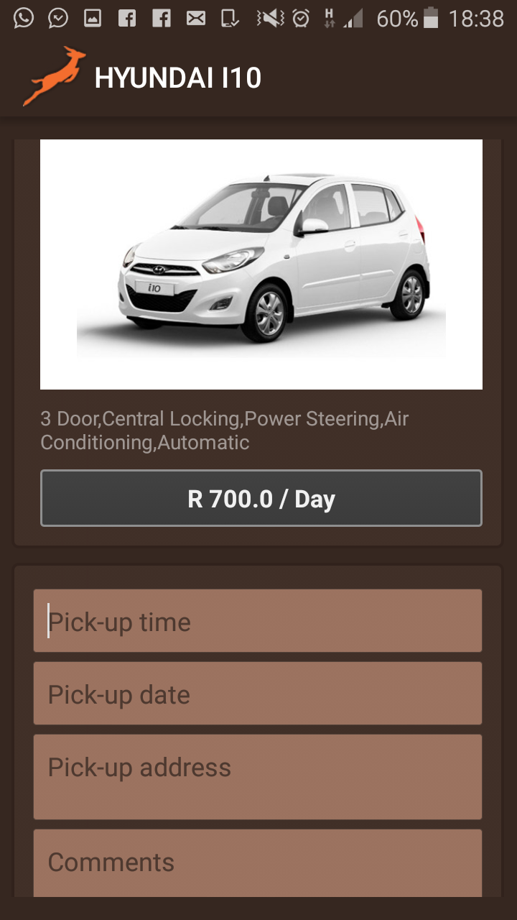

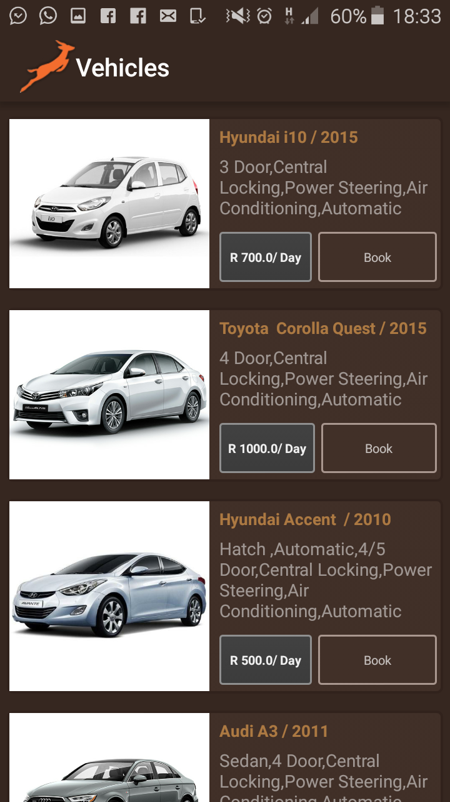

### Test case 5: Accommodation

**Purpose**: Verify that a member can properly quote for accommodation.

**Requirement Traceability**: A member must be registered. And be on menu Screen

**Setup**: The Riki Tour app is started and member logs in.

**Test Data**:

|  |  |  |
| --- | --- | --- |
| **Action** | **Input** | **Expected Output** |
|  |  | Menu Screen |
| Click Accommodation |  | Accommodations Screen |
| Click Read More |  | Detail Screen per Accommodation |
| Click Book now |  | “Quote request successfully received” |
| Click Gallery |  | Accommodation Gallery |

### C:\Users\bishop v\Desktop\app pics\acc.png

### Test case 6: Help Button

**Purpose**: To get Help and access FAQ’s and using the app

**Requirement Traceability**: A member must be registered. And be on menu Screen

**Setup**: The Riki Tour app is started and member logs in.

**Test Data**:

|  |  |  |
| --- | --- | --- |
| **Action** | **Input** | **Expected Output** |
|  |  | Menu Screen |
| Click Help Button |  | Help Screen displayed with detailed list of help service available and FAQ’s Solutions |

### Test case 7: About RIKI

**Purpose**: History about the Company and Services Provided

**Requirement Traceability**: A member must be registered. And be on menu Screen

**Setup**: The Riki Tour app is started and member logs in.

**Test Data**:

|  |  |  |
| --- | --- | --- |
| **Action** | **Input** | **Expected Output** |
|  |  | Menu Screen |
| Click About Riki |  | displayed about screen with information about the company and the Stakeholder’s of the company |

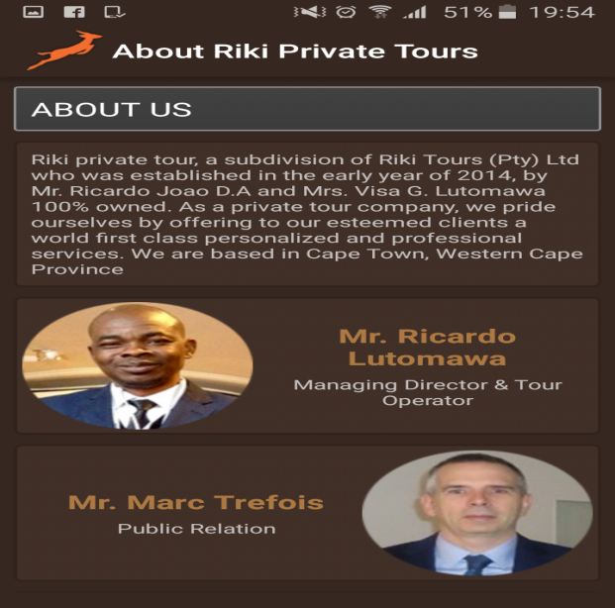

### Test case 8: About App

**Purpose**: Display General Information about the app

**Requirement Traceability**: A member must be registered. And be on menu Screen

**Setup**: The Riki Tour app is started and member logs in.

**Test Data**:

|  |  |  |
| --- | --- | --- |
| **Action** | **Input** | **Expected Output** |
|  |  | Menu Screen |
| Click About App |  | About App Screen |

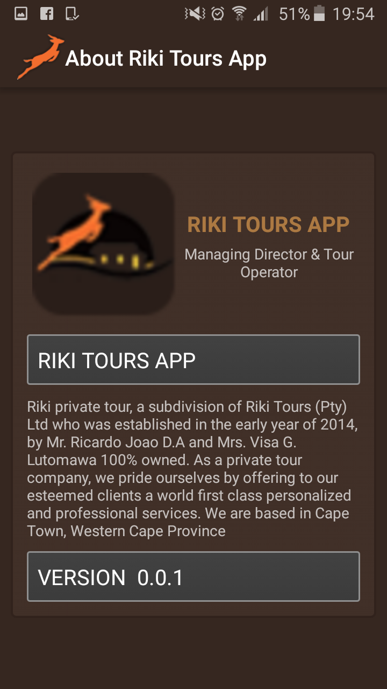

### Test case 8: Profile

**Purpose**: Display General Information about registered member.

**Requirement Traceability**: A member must be registered. And be on menu Screen

**Setup**: The Riki Tour app is started and member logs in.

**Test Data**:

|  |  |  |
| --- | --- | --- |
| **Action** | **Input** | **Expected Output** |
|  |  | Menu Screen |
| Click Menu Icon |  | Menu Panel |
| Click My Profile |  | User Profile displays |

